🌱 CuttingGardens 2026
THE SAN DIEGO GARDEN

Scientific Program — Sessions, Speaker Profiles & Abstracts
Global CuttingGardens Week: September 21–25, 2026
San Diego Garden: September 23–24, 2026
Venue: San Diego Supercomputer Center (SDSC), UC San Diego
Organized by: Brainstorm Team (USC) & EEGLAB Team (UCSD)
DRAFT v3
Working draft for the Organizing Committee. Talks marked PROVISIONAL are committee-drafted placeholders pending speaker confirmation.

About the San Diego Garden

CuttingGardens 2026 is a worldwide event organized as a network of more than 20 local "Gardens" across six continents, all connected through a shared international scientific program. Participants attend their local Garden while engaging with researchers around the world through live keynote sessions, discussions, and collaborative activities.
The San Diego Garden is jointly organized by the Brainstorm Team at the University of Southern California (USC) and the EEGLAB Team at the University of California San Diego (UCSD), bringing together two of the world's leading open-source neuroscience platforms. Day 1 opens with introductions to the major open-source analysis platforms and closes with an afternoon practicum on deep learning for EEG; Day 2 is a scientific symposium organized into five thematic sessions spanning wearable neural interfaces, multimodal EEG-fMRI, open data and machine learning, analysis methodology, and clinical translation and wellbeing.

Program at a Glance (Final version will be released asap)

Time | Day 1 — Wed Sep 23 | Day 2 — Thu Sep 24
08:30 | Global Program | Global Program
09:00 | Welcome Desk + Coffee; Opening (R. Leahy) | Coffee
09:30 | EEGLAB Introduction (A. Delorme); Brainstorm Introduction (T. Medani); BrainSuite for fMRI (D. Shattuck & A. Joshi) | Session 1 — Wearable & Real-World Neural Interfaces
11:00 | Mobile Brain Imaging (S. Makeig); Exhibitor Talks (TBC) | Session 2 — Multimodal EEG-fMRI
12:00 | Lunch break & Poster Session | Lunch break & Poster Session
13:00 | (lunch & posters continue) | Session 3 — Open Data & Machine Learning
14:00 | PRACTICUM — Deep Learning EEG Methods and Practice | Session 4 — Rethinking Measurement
15:30 | (practicum continues) | Session 5 — Clinical Translation, Mental Health & Wellbeing
17:00 | Wrap-up + Q&A | Closing Remarks
18:00 | Reception / Social Event | —
Poster sessions run throughout both days with extended discussion breaks. Schedule subject to change.

Sponsors & Partners

We gratefully acknowledge the organizations whose support makes the San Diego Garden possible. Additional sponsorship and exhibitor opportunities remain available for organizations interested in connecting with the international EEG and neuroimaging community.
PLATINUM SPONSORS
▢ logo  Wearable Sensing | ▢ logo  Advanced Brain Monitoring  (ABM) | ▢ logo  ANT Neuro  (North America)
▢ logo  Cortech Solutions | ▢ logo  CGX

LOCAL ORGANIZING PARTNERS
▢ logo  University of Southern California  USC — Brainstorm Team | ▢ logo  UC San Diego  UCSD — EEGLAB Team | ▢ logo  San Diego Supercomputer Center  SDSC
Sponsor tiers and logos to be confirmed; drop each organization's logo into its box.

Day 1 — Wednesday, September 23
Opening, software introductions & hands-on workshops

1. Richard Leahy 09:15
Dean's Professor of ECE, Biomedical Engineering & Radiology; Director, USC Signal and Image Processing Institute — University of Southern California
 | BIOGRAPHY  Richard Leahy is Dean's Professor of Electrical & Computer Engineering, Biomedical Engineering, and Radiology at the University of Southern California, and Director of the USC Signal and Image Processing Institute, where he leads the Biomedical Imaging Group. He earned his PhD in electrical engineering from the University of Newcastle upon Tyne and has spent his career developing signal and image processing methods for the formation and analysis of biomedical images, with applications in EEG/MEG source imaging, PET, and MRI. He is a co-creator of the open-source Brainstorm and BrainSuite software packages, a Fellow of the IEEE, and a recipient of the IEEE Hoffman Medical Imaging Scientist Award. He has published more than 200 papers in biomedical signal and image processing.
  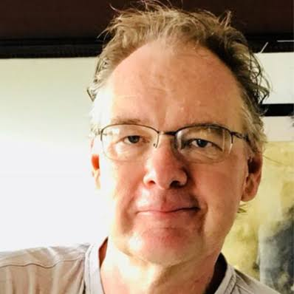

TALK TITLE
Opening of the San Diego Garden & Intro to multimodal neuroimaging
ABSTRACT
To be provided by the speaker.

2. Arnaud Delorme 09:30
Professor, Paul Sabatier University (CNRS); Project Scientist & Chief Software Architect of EEGLAB, Swartz Center for Computational Neuroscience — UC San Diego
 | BIOGRAPHY  Arnaud Delorme is a Professor at Paul Sabatier University in Toulouse (CNRS) and Project Scientist and Chief Software Architect of EEGLAB at the Swartz Center for Computational Neuroscience, UC San Diego. With Scott Makeig he co-created EEGLAB, now one of the most widely used open-source environments for EEG analysis, and he continues to lead its development and the Open EEGLAB Portal. His research spans independent component analysis, the neural correlates of consciousness, meditation, and mind-wandering, and he is among the most highly cited researchers in the EEG methods community.
  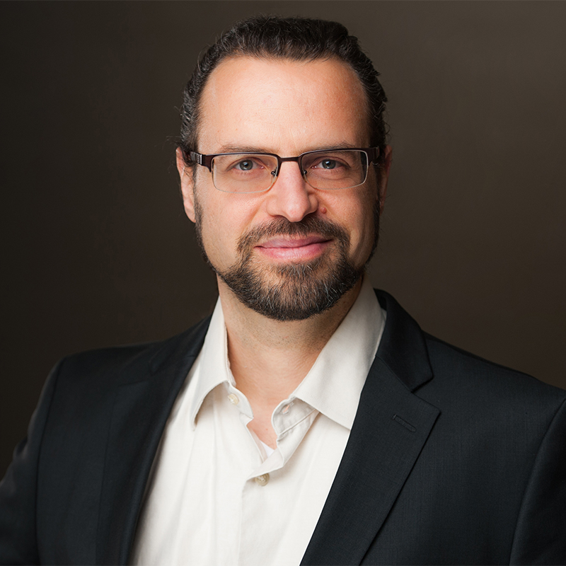

TALK TITLE
EEGLAB Introduction
ABSTRACT
To be provided by the speaker.

3. Takfarinas Medani 10:00
Research Scientist, Ming Hsieh Department of Electrical and Computer Engineering; Biomedical Imaging Group — University of Southern California
 | BIOGRAPHY  Takfarinas Medani is a Research Scientist in the Ming Hsieh Department of Electrical and Computer Engineering at USC, working within the Biomedical Imaging Group and the Signal and Image Processing Institute. He is a core developer of Brainstorm and led the integration of the DUNEuro finite-element method into the software, enabling realistic finite-element modeling of electromagnetic brain activity. His work centers on multimodal EEG/MEG/sEEG signal processing, forward and inverse source modeling, and the translation of these open-source tools to clinical neuroscience and epilepsy research.
  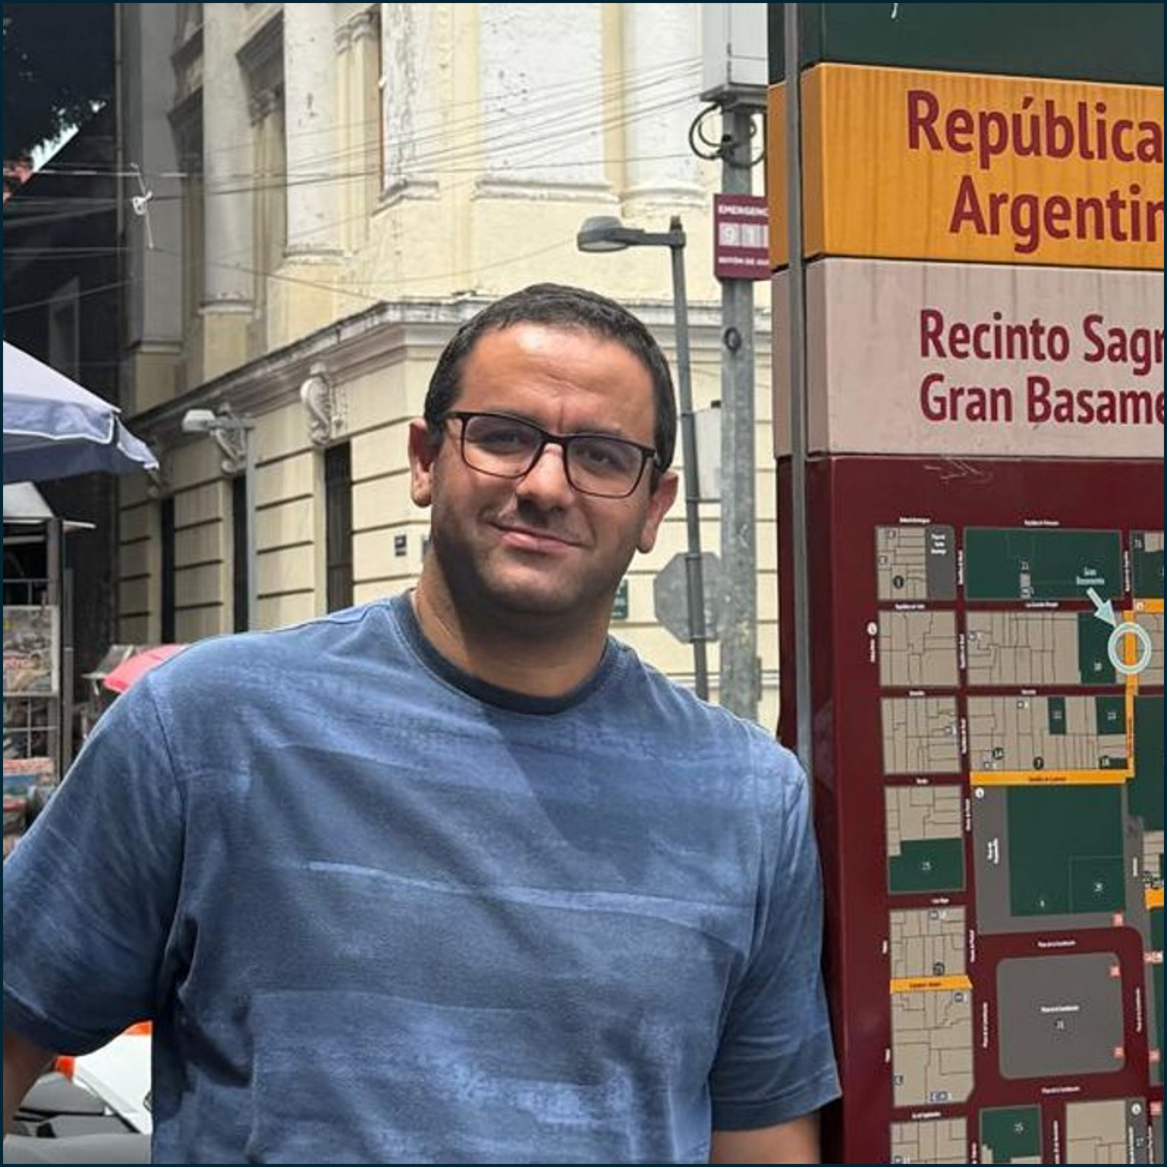

TALK TITLE
Brainstorm Introduction
ABSTRACT
To be provided by the speaker.

4. David Shattuck & Anand Joshi 10:30
David Shattuck — Professor of Neurology, UCLA (Ahmanson-Lovelace Brain Mapping Center) • Anand Joshi — Research Associate Professor of ECE, University of Southern California
 | BIOGRAPHY  David Shattuck is a Professor in the Department of Neurology at the David Geffen School of Medicine at UCLA and a member of the Ahmanson-Lovelace Brain Mapping Center. He received his PhD in electrical engineering from USC and develops computational methods for processing and analyzing brain images, including segmentation, topological correction, registration, and cortical surface extraction. He is a co-developer of BrainSuite, a widely used open-source package for structural and diffusion MRI analysis.Anand Joshi is a Research Associate Professor in the Ming Hsieh Department of Electrical and Computer Engineering at USC. He holds a PhD in electrical engineering and an MA in mathematics from USC, followed by postdoctoral training at the UCLA Laboratory of Neuro Imaging. His research focuses on brain image analysis, geometric methods, partial differential equations, and machine learning, and he is a long-standing contributor to the BrainSuite software and to joint EEG/MRI analysis pipelines.
  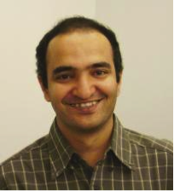

TALK TITLE
BrainSuite for fMRI Analysis
ABSTRACT
To be provided by the speaker.
NOTE
Joint presentation by the two co-developers of BrainSuite. Individual photos can be placed side by side.

5. Scott Makeig 11:00
Founding Director, Swartz Center for Computational Neuroscience — UC San Diego
 | BIOGRAPHY  Scott Makeig is the founding Director of the Swartz Center for Computational Neuroscience at UC San Diego and, with Arnaud Delorme, the originator and co-developer of EEGLAB. He earned his PhD from UC San Diego and pioneered the application of independent component analysis to EEG as well as the paradigm of Mobile Brain/Body Imaging (MoBI), which jointly records brain activity, the sensory scene, and behavior in freely moving participants. His work centers on the analysis and modeling of human cognitive event-related brain dynamics across EEG, MEG, and other modalities.
  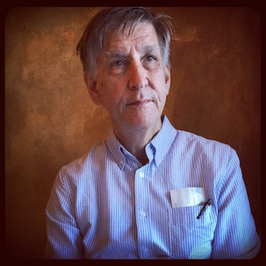

TALK TITLE
Mobile Brain Imaging
ABSTRACT
To be provided by the speaker.

AFTERNOON PRACTICUM • 14:00 – 17:00
Deep Learning EEG Methods and Practice
A single unified hands-on session, replacing the previously planned parallel Brainstorm and EEGLAB workshops.
OVERVIEW
This tutorial covers how to preprocess EEG data using EEGLAB, Brainstorm, MNE-Python, and EEGPrep, as well as how to apply deep learning to EEG data using PyTorch-compatible libraries and frameworks such as Braindecode and NeuroAI. The tutorial combines theory with light hands-on practice on existing EEG foundation models.
PART 1 — PREPROCESSING ACROSS PLATFORMS
- EEGLAB — established MATLAB pipelines for cleaning and decomposition
- Brainstorm — integrated preprocessing, source modeling, and visualization
PART 2 — DEEP LEARNING ON EEG
Four self-contained Google Colab notebooks, run on free cloud GPUs with no local installation. Each builds on the previous one, and each ends with a reusable template participants can take back to their own data.
- 1 · From Data to Model — the core Braindecode pipeline. Converting EEGLAB/MNE-preprocessed recordings into PyTorch Dataset and DataLoader objects, then training classic built-in models (EEGNet, ShallowFBCSPNet). Covers the format-conversion step that most often blocks beginners.
- 2 · Adding Attention — Transformers for EEG. Patching and tokenization of continuous time-series EEG, a compact ViT-style encoder built from scratch, and attention visualization — the vocabulary needed to work with foundation models.
- 3 · Standing on the Shoulders of Giants — fine-tuning EEG foundation models. Self-supervised pretraining on unlabeled EEG, then transfer to a held-out subject: linear probing, full fine-tuning, and partial freezing, with the label-efficiency curve that motivates the approach. Includes the practical recipe for loading published checkpoints (LaBraM, BENDR, EEGPT).
- 4 · Broadening the Scope — multimodal alignment and fusion (bonus). Temporally aligning EEG with a second modality such as eye-gaze, and feeding both into a two-stream network — early, late, and attention-based fusion.
All notebooks use the public BCI Competition IV 2a motor-imagery dataset, downloaded automatically — no data preparation or account is required. Materials are available in advance so participants can run them during or after the session.
FORMAT
Theory interleaved with light hands-on practice. Participants are encouraged to bring a laptop; the deep-learning notebooks run entirely in Google Colab, so only a browser and a Google account are needed — no local installation. Prerequisites, setup instructions, and datasets will be circulated in advance of the meeting.
INSTRUCTORS
Kung-Yi Chang — Ph.D. candidate, National Tsing Hua University; visiting researcher, Swartz Center for Computational Neuroscience, UC San Diego. Deep learning for EEG and multimodal neural signals.
Contributing the Part 2 deep-learning practicum (Braindecode, Transformers, EEG foundation models, and multimodal fusion).
Additional instructors for Part 1 (preprocessing across platforms) to be confirmed; the full teaching team will be listed here.
COMMITTEE NOTE — CALL FOR CONTRIBUTORS
If a student or colleague has a model that should be included, or already has teaching material prepared and would be interested in contributing, the organizing committee would be glad to consider it. Please remove this box before the program is circulated publicly.

Day 2 — Thursday, September 24
Scientific symposium — five thematic sessions of invited local talks
SESSION MAP
# | Time | Theme | Speakers
1 | 09:30–10:30 | Wearable & Real-World Neural Interfaces | T.-P. Jung; G. Cauwenberghs
2 | 11:00–12:00 | Multimodal EEG-fMRI: Acquisition & Analysis | P. Razmara; A. Lenartowicz
3 | 13:00–14:00 | Open Data & Machine Learning for EEG | S. Y. Shirazi; V. de Sa
4 | 14:00–15:00 | Rethinking Measurement: Naturalistic Recording & Analysis Assumptions | Y. C. Wu; B. Voytek
5 | 15:30–17:00 | Clinical Translation, Mental Health & Wellbeing | K. Avramidis; A. Habibi; R. Cahn

SESSION 1 • 09:30 – 10:30
Wearable & Real-World Neural Interfaces
Moving EEG out of the shielded room: unobtrusive, wearable and in-ear sensing hardware, closed-loop neurofeedback, and brain–computer interfaces designed for unconstrained, actively engaged people.

6. Tzyy-Ping Jung 09:30 – 10:00
Associate Director, Swartz Center for Computational Neuroscience; Co-Director, Center for Advanced Neurological Engineering — UC San Diego
 | BIOGRAPHY  Tzyy-Ping Jung is Associate Director of the Swartz Center for Computational Neuroscience and Co-Director of the Center for Advanced Neurological Engineering at UC San Diego, where he is also an Adjunct Professor of Bioengineering. An IEEE Fellow, he was present at the origins of EEGLAB and has helped shape the fields of independent component analysis, brain–computer interfaces, and wearable dry-electrode EEG. His research advances biomedical signal processing, machine learning, and real-world neuroimaging aimed at monitoring cognition in unconstrained, actively engaged people, including SSVEP-based BCIs and clinical applications such as the nGoggle headset for visual-field assessment.
  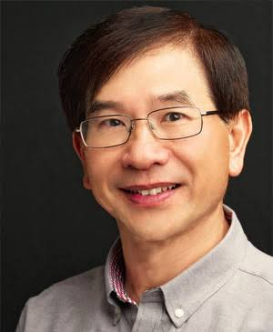

TALK TITLE
⚠ PROVISIONAL — awaiting speaker confirmation
Real-World Neuroimaging and Wearable Brain–Computer Interfaces
EXPECTED SCOPE (DRAFTED BY THE COMMITTEE)
Expected to cover real-world neuroimaging and wearable brain–computer interfaces: dry-electrode and wireless EEG systems for recording in unconstrained, actively engaged participants; SSVEP- and P300-based BCI paradigms and recent machine-learning approaches to cross-subject decoding; and translational applications including cognitive-state and attention monitoring and headset-based clinical assessment.
Basis for this placeholder: drafted from Dr. Jung's stated research focus and recent publications (SSVEP/BCI decoding, wearable dry-electrode EEG, real-world neuroimaging). Not yet reviewed by the speaker.

7. Gert Cauwenberghs 10:00 – 10:30
Distinguished Professor of Bioengineering; Co-Director, Institute for Neural Computation — UC San Diego
 | BIOGRAPHY  Gert Cauwenberghs is a Distinguished Professor of the Shu Chien-Gene Lay Department of Bioengineering in the Jacobs School of Engineering and Co-Director of the Institute for Neural Computation in the Halıcıoğlu School of Data Science and Computing at UC San Diego. His research focuses on neuromorphic engineering, adaptive intelligent systems, neuron-silicon and brain-machine interfaces, and micropower biomedical instrumentation. He has pioneered the engineering of silicon integrated circuits that emulate the fundamental physical principles, structural organization, and cognitive function of the computational brain. Operating at extreme levels of energy efficiency and noise resilience, these integrated circuits have shown great use for ubiquitous deployment of engineered natural intelligence for applications ranging from human-computer interaction to wearable health monitoring.
  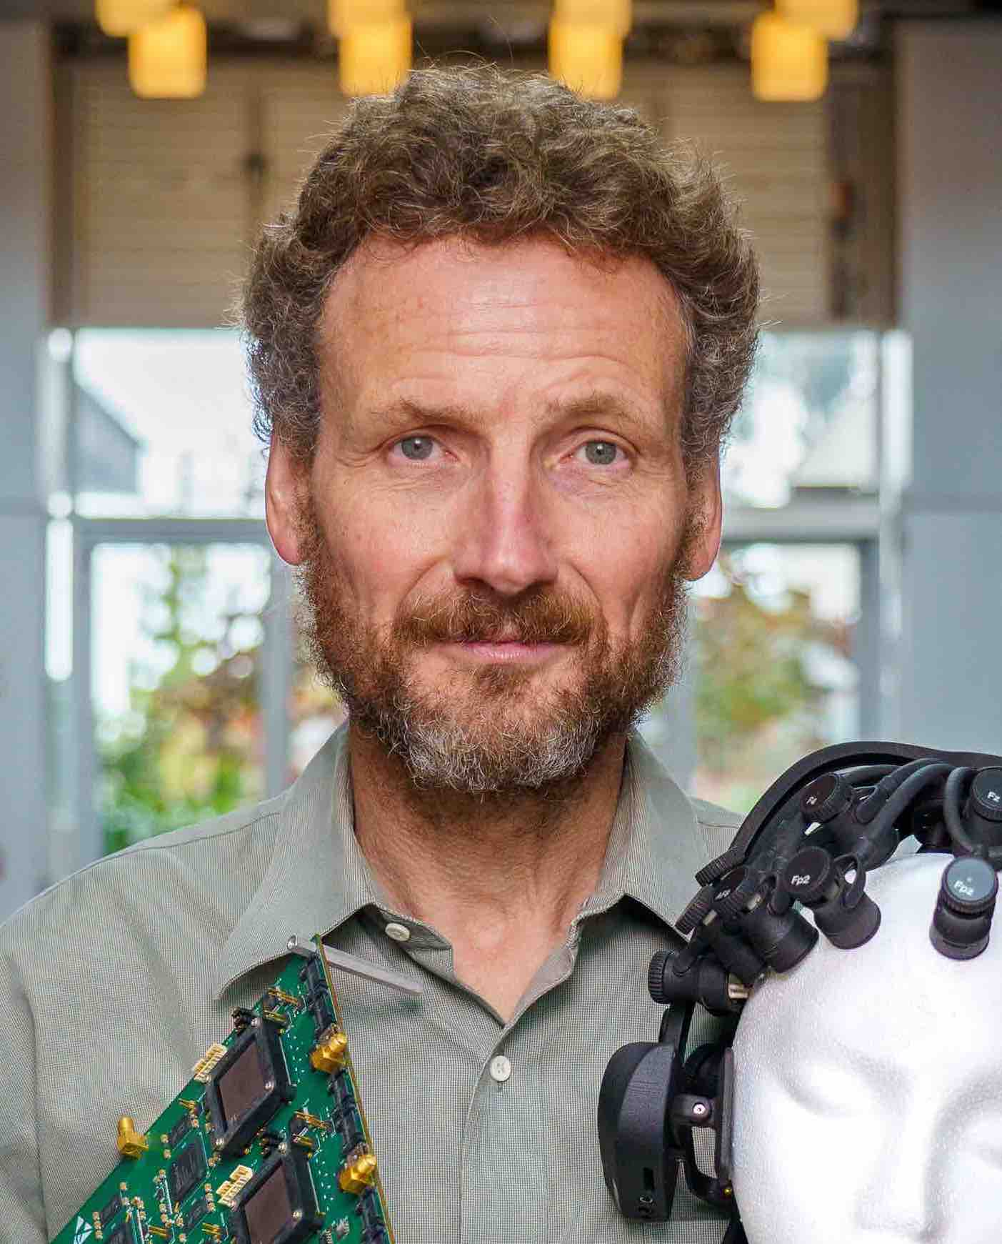

TALK TITLE
Unobtrusive in-ear EEG neural interfaces with closed-loop auditory neurofeedback for brain-body health and wellness
ABSTRACT
The convergence of neurotechnology and adaptive machine intelligence onto low-power silicon integrated systems offers opportunities to advance the effectiveness, efficiency, affordability, and comfort of mobile brain-computer and human-machine interfaces for applications ranging from hands-free voiceless communication to continuous health monitoring and biofeedback electroceutical therapy. I will highlight advances in the miniaturization and integration of neural interfaces with embedded active electronics operating at record levels of noise-energy efficiency providing microvolt and femtoampere sensitivity at microwatt power, with a focus on unobtrusive wearable systems for probing and controlling brain activity with minimal contact and discomfort to the body. These include flexible in-ear sensors mounted on a user-generic earbud recording electrophysiological and electrochemical signals indicative of brain cognitive activity as well as body metabolic state for unobtrusive continuous health and wellness monitoring. I will also discuss implications of these advances and related developments in body area networks to new and emerging applications of pervasive neural interfaces for closed-loop neurological monitoring and neurofeedback therapy.

☕ 10:30 – 11:00 Break / Coffee
SESSION 2 • 11:00 – 12:00
Multimodal EEG-fMRI: Acquisition & Analysis
Two complementary perspectives on concurrent electrophysiology and functional MRI — the practical physics of recording and denoising inside the scanner, and the analytical pipelines that extract joint neural-haemodynamic information.

8. Parsa Razmara 11:00 – 11:30
Researcher, Biomedical Imaging Group (Leahy Lab) — University of Southern California
 | BIOGRAPHY  Parsa Razmara is a researcher in Richard Leahy's Biomedical Imaging Group at USC. His work focuses on multimodal EEG-fMRI acquisition and analysis in technically challenging MRI environments, including proof-of-concept simultaneous EEG-fMRI at low field strength (0.55T), artifact characterization and denoising, and functional mapping, extending toward real-time MRI and EMG studies of speech production.
  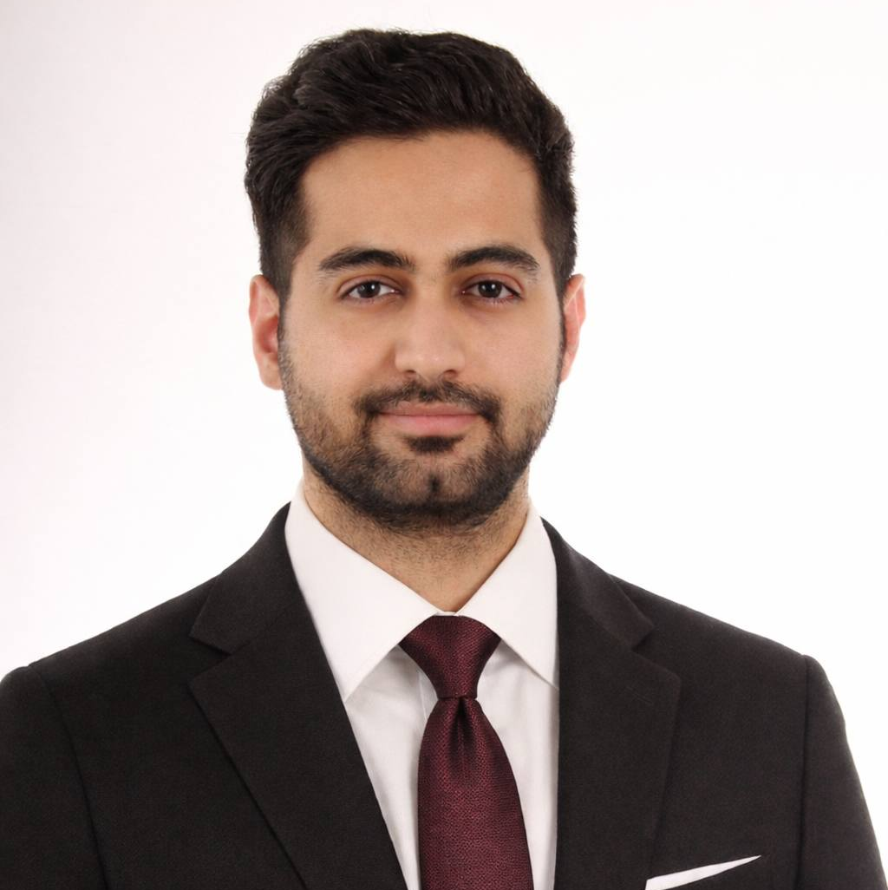

TALK TITLE
Multimodal EEG in the MRI Environment: From Low-Field EEG-fMRI to Speech Neurophysiology
ABSTRACT
This talk discusses recent work on simultaneous EEG-fMRI at 0.55T, focusing on recording, denoising, scanner-related artifacts, and multimodal functional mapping. It then connects this to work on EEG and EMG acquisition during real-time MRI of speech production, as a second example of multimodal EEG acquisition in technically challenging MRI environments. The aim is to frame the talk around artifact-aware multimodal neuroimaging methods rather than fMRI alone.

9. Agatha Lenartowicz 11:30 – 12:00
Professor, Department of Psychiatry & Biobehavioral Sciences, Semel Institute — UCLA
 | BIOGRAPHY  Agatha Lenartowicz is a Professor in the Department of Psychiatry & Biobehavioral Sciences at the David Geffen School of Medicine, UCLA, faculty at the Semel Institute for Neuroscience and Human Behavior and Associate Director of the Staglin Center for Cognitive Neuroscience. Her research addresses the source mechanisms and neural dynamics of attention deficits, including ADHD, using multimodal EEG and fMRI across temporal scales and states, with a particular emphasis on translating findings to real-life contexts such as classrooms.
  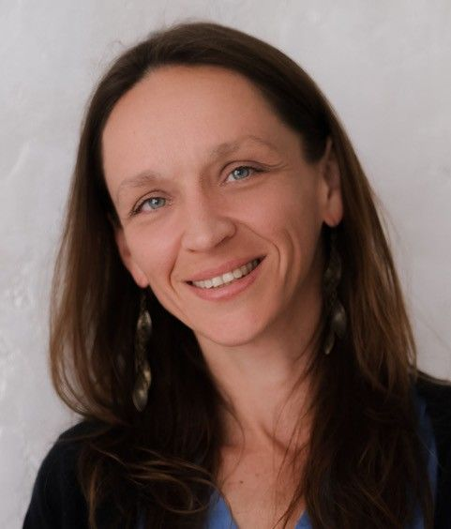

TALK TITLE
Concurrent EEG-fMRI: Acquisition & Analysis
ABSTRACT
Concurrent recording of multimodal data is a powerful tool for investigating the mechanisms underlying joint neural and cognitive dynamics. This presentation provides an overview of the fundamentals of concurrent EEG-fMRI acquisition and explores the analytical pipelines currently available to extract joint information. Attendees will gain an understanding of the application domains, and limitations, of concurrent acquisition techniques.

🍽 12:00 – 13:00 Lunch Break & Poster Session
SESSION 3 • 13:00 – 14:00
Open Data & Machine Learning for EEG
Open, richly annotated data at scale, and the models trained on it: first the infrastructure that makes large EEG datasets reusable and machine-learning-ready, then a critical look at how well current EEG foundation models actually transfer to fine-grained decoding tasks.

10. Seyed Yahya Shirazi 13:00 – 13:30
Assistant Project Scientist & Principal Investigator, Swartz Center for Computational Neuroscience — UC San Diego
 | BIOGRAPHY  Seyed Yahya Shirazi is an Assistant Project Scientist and Principal Investigator at the Swartz Center for Computational Neuroscience, Institute for Neural Computation, UC San Diego. His research integrates computational neuroscience with human cognition and movement, focusing on EEG/EMG signal processing, neuromechanics, and Mobile Brain/Body Imaging for clinical rehabilitation. He led the curation and HED annotation of the Healthy Brain Network EEG dataset (HBN-EEG, 3,600+ participants across 11 releases), is lead scientist for the BIDS extension proposals for EMG and Stimulus, and is a core member of the HED working group and an organizer of the EEG Foundation Challenge.
  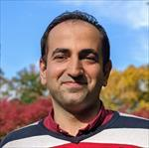

TALK TITLE
⚠ PROVISIONAL — awaiting speaker confirmation
Open, Large-Scale EEG: HBN-EEG, BIDS/HED Annotation and the EEG Foundation Challenge
EXPECTED SCOPE (DRAFTED BY THE COMMITTEE)
Expected to cover large-scale, open and reusable EEG: the curation of the Healthy Brain Network EEG dataset (HBN-EEG) into BIDS with Hierarchical Event Descriptor (HED) annotation across 11 releases and more than 3,600 participants aged 5–21; distribution through NEMAR and the Neuroscience Gateway; and how richly annotated open data enables cross-task and cross-subject machine learning, as showcased in the EEG Foundation Challenge.
Basis for this placeholder: drafted from Dr. Shirazi's HBN-EEG dataset releases, BIDS/HED standardisation work, and his role in the EEG Foundation Challenge. Not yet reviewed by the speaker.

11. Virginia de Sa 13:30 – 14:00
Professor of Cognitive Science, HDSI Chancellor's Endowed Chair; Associate Director, Halıcıoğlu Data Science Institute — UC San Diego
 | BIOGRAPHY  Virginia de Sa is a Professor of Cognitive Science and HDSI Chancellor's Endowed Chair at UC San Diego, where she is also Associate Director of the Halıcıoğlu Data Science Institute. She earned her PhD in Computer Science from the University of Rochester and works at the intersection of cognitive science, neuroscience, and machine learning, studying how humans and machines learn to perceive. Her lab's recent work spans motor-imagery brain–computer interfaces, decoding of imagined handwriting from EEG, subject-transfer calibration, and the evaluation of EEG foundation models.
  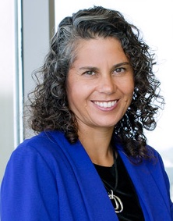

TALK TITLE
⚠ PROVISIONAL — awaiting speaker confirmation
Decoding Motor Imagery from EEG: Foundation Models, Imagined Handwriting and Practical BCIs
EXPECTED SCOPE (DRAFTED BY THE COMMITTEE)
Expected to cover machine-learning approaches to EEG decoding for brain–computer interfaces: motor-imagery BCIs and the practical problem of calibration under data constraints via subject transfer; decoding of imagined handwriting as a fine-grained, high-information-rate control signal; and a critical evaluation of how current EEG foundation models perform against task-specific architectures.
Basis for this placeholder: drafted from the de Sa Lab's 2025–2026 publications on motor-imagery BCIs, imagined-handwriting decoding, and EEG foundation models. Not yet reviewed by the speaker.

SESSION 4 • 14:00 – 15:00
Rethinking Measurement: Naturalistic Recording & Analysis Assumptions
A methodological pairing. Both talks show how default analytical choices — what we time-lock to, and how we decompose a spectrum — can silently determine, and distort, the conclusions we draw from EEG.

12. Ying Choon Wu 14:00 – 14:30
Assistant Project Scientist, Institute for Neural Computation & Swartz Center for Computational Neuroscience — UC San Diego
 | BIOGRAPHY  Ying Choon Wu is an Assistant Project Scientist at the Institute for Neural Computation and the Swartz Center for Computational Neuroscience, UC San Diego. A cognitive neuroscientist, she studies brain systems underlying higher-order cognition — including insight, multimodal discourse and gesture comprehension, and problem solving — and develops portable, wearable MoBI approaches that synchronize EEG, eye tracking, and other biosignals during real-world activities in naturalistic and virtual environments.
  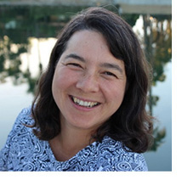

TALK TITLE
Free-Moving Gaze-related Electroencephalography in Mobile Virtual Environments
ABSTRACT
In realistic contexts involving natural, unconstrained head and body movement, methods for parsing eye movements and using these segmentations to analyze other modalities of synchronously recorded physiological data are still in their infancy. In two studies, we recorded eye and head movements, along with simultaneous electroencephalography (EEG), during a 3D visual oddball task in a virtual environment. Healthy adults evaluated standards and deviants presented to their near or far peripheral field of view either by moving their eyes only (low head movement, HM) or turning their heads (high HM). Compensatory eye movements — likely related to the vestibulo-ocular reflex — accompanied high HM, suggesting the possible inadequacy of algorithms based purely on the angular velocity of pupil movement for parsing fixations and saccades during head movement, as visual processing likely begins before compensatory eye movement attenuates.
We compared three approaches to computing fixation-related potentials (FRPs) for detecting P300 oddball responses during either low or high HM. Stimulus-locking aligned EEG epochs to stimulus onset; fixation-locking aligned to the onset of fixations detected by a Tobii I-VT velocity threshold; and gaze-intersection-point (GIP)-locking aligned to the moment the gaze vector intersected the target. Under both low and high HM, fixation-locking and GIP-locking yielded classic oddball effects within the expected P300 window, whereas stimulus-locking did not. GIP-locking yielded slightly better results during high HM in the absence of overt decision-related responses. These outcomes reveal that, despite uncertainty in fixation onset times during head turns, gaze-locking approaches incorporating gaze information are viable in paradigms involving head movement.

13. Bradley Voytek 14:30 – 15:00
Professor & Chair of Cognitive Science; Halıcıoğlu Data Science Institute — UC San Diego
 | BIOGRAPHY  Bradley Voytek is Professor and Chair of Cognitive Science at UC San Diego, with additional appointments in the Halıcıoğlu Data Science Institute and the Neurosciences Graduate Program. An Alfred P. Sloan Research Fellow and Kavli Fellow, he studies aperiodic and oscillatory neural activity and their roles across cognition, development, aging, and disease. After completing his PhD at UC Berkeley he became Uber's first data scientist before joining the UC San Diego faculty.
  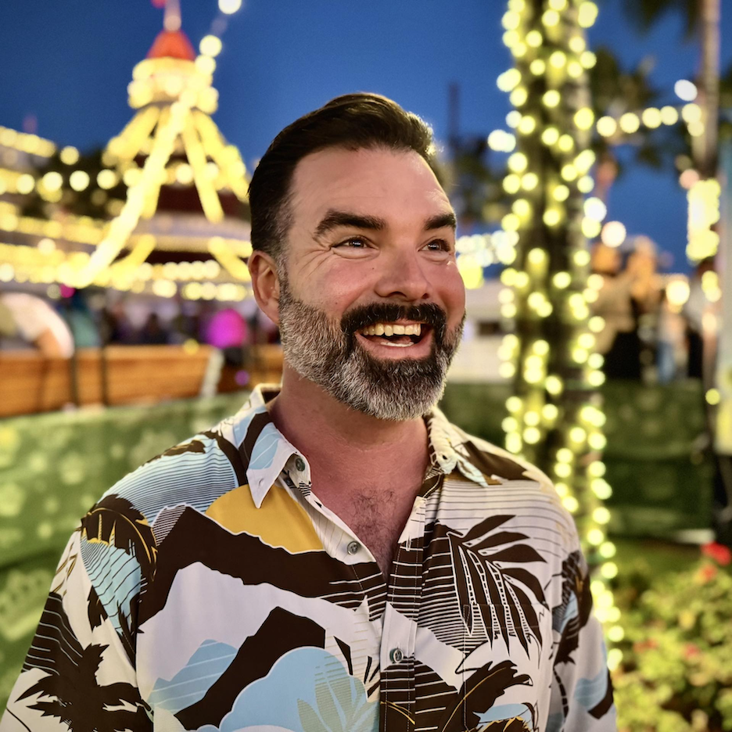
TALK TITLE
Our neuroscience methods constrain our neuroscience theories
ABSTRACT
The methods we use to quantify neural data constrain our theories of neural computation, cognition, and disease. This talk argues that standard analytical approaches have systematically biased neuroscience toward overly simplified, and perhaps incorrect, models of neural computation and communication. By revisiting neural data with methods that explicitly quantify the rich variability of our signals — from the aperiodic structure of local field potentials and EEG, to the shape of neural oscillations and even of individual action potentials — we can uncover richer physiological insights and develop more accurate, mechanistic theories of brain function.

☕ 15:00 – 15:30 Break / Coffee
SESSION 5 • 15:30 – 17:00
Clinical Translation, Mental Health & Wellbeing
From measurement to intervention in mental health: multimodal markers of psychiatric state, then two programmes that use electrophysiology to evaluate very different interventions — sustained music engagement across the lifespan, and psilocybin-assisted therapy.

14. Kleanthis Avramidis 15:30 – 16:00
PhD Candidate, Department of Computer Science; Signal Analysis and Interpretation Laboratory (SAIL) — University of Southern California
 | BIOGRAPHY  Kleanthis Avramidis is a PhD candidate in Computer Science at USC, advised by Professor Shrikanth Narayanan in the Signal Analysis and Interpretation Laboratory (SAIL). Originally from Athens, Greece, he works on human-centered machine intelligence, with interests spanning signal processing and multimodal biosignal analysis — including ECG and EEG representation learning and physiological markers of mental health such as depression and suicidal ideation.
  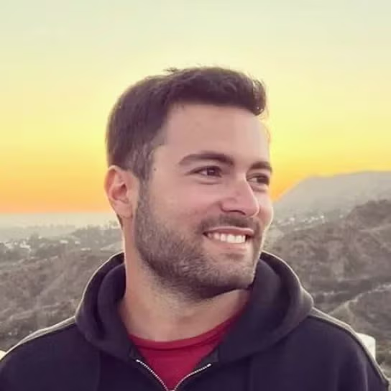

TALK TITLE
Scaling Psychiatric Biomarkers in Context and Time: Lessons from the PRECOG Project
ABSTRACT
Biomarkers of psychiatric illness are typically estimated from short controlled recordings and evaluated within a single lab session. PRECOG was designed to test what happens when both of these constraints are relaxed. Across 160 control and clinical participants, we collected concurrent EEG, eye tracking, physiology, and facial video during a battery of cognitive and affective tasks. This talk covers three aspects of the work. First, the challenge of aligning physiological modalities during data collection and analysis. Second, results from analyses of EEG, peripheral autonomic, and oculomotor signals, focusing on what each modality captures and where they converge. Third, the design of a forthcoming longitudinal extension, which enriches group classification with insights into within-subject progression.

15. Assal Habibi 16:00 – 16:30
Associate Professor of Psychology, Co-Director, Brain and Creativity Institute; Director, Center for Music, Brain and Society — University of Southern California
 | BIOGRAPHY  Assal Habibi, PhD is an Associate Professor of Psychology and Neurology at the University of Southern California, where she serves as Co-Director of the USC Brain and Creativity Institute and Director of the USC Center for Music, Brain, and Society. Her research examines how music and other enriching experiences shape brain development, neuroplasticity, and cognitive, emotional, and social functioning across the lifespan. Using multimodal approaches—including high-density EEG, MRI, psychophysiology, and longitudinal randomized controlled trials—her work investigates the neural mechanisms through which music influences learning, healthy aging, and mental health.  Dr. Habibi leads several NIH- and NEA-funded studies, including one of the longest longitudinal investigations of childhood music training and brain development to date, as well as clinical trials examining the effects of choir participation on auditory, cognitive, and socioemotional health in older adults. Her laboratory also applies advanced electrophysiological methods to study auditory processing, executive function, speech-in-noise perception, and neurophysiological markers associated with mood disorders and suicide risk. A classically trained pianist, Dr. Habibi's work integrates neuroscience, psychology, and the arts to better understand how enriching experiences promote lifelong brain health and resilience.
  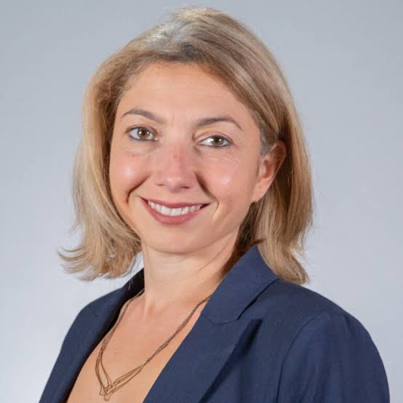

TALK TITLE
⚠ PROVISIONAL — awaiting speaker confirmation
The Brain's Crescendo: Electrophysiological Signatures of Music-Induced Neuroplasticity Across the Lifespan
ABSTRACT
Music provides a powerful model for understanding experience-dependent neuroplasticity and the neural mechanisms that support learning across the lifespan. This presentation will integrate evidence from cross-sectional, longitudinal, and intervention studies to demonstrate how musical engagement shapes auditory, cognitive, and socioemotional brain function from childhood through older adulthood.
I will first review electrophysiological studies comparing musicians and non-musicians, highlighting differences in auditory event-related potentials that reflect enhanced sensory encoding, neural efficiency, selective attention, and cognitive control in individuals with musical expertise. I will then present findings from longitudinal studies of children participating in intensive community-based music programs, demonstrating that music training is associated with improvements in executive function, accelerated maturation of auditory and frontal brain networks, and longitudinal changes in auditory and cognitive ERPs. Finally, I will discuss recent intervention studies in older adults showing that participation in community choir programs enhances speech-in-noise perception and modulates both early sensory and later cognitive auditory evoked responses, providing evidence that meaningful neuroplasticity extends into later life.The presentation will emphasize how electrophysiological approaches can be used to identify sensitive markers of experience-dependent brain plasticity, providing new insights into the neural mechanisms through which musical engagement shapes perception, cognition, and adaptive brain function across the lifespan.

16. Rael Cahn 16:30 – 17:00
MD, PhD — Clinical Associate Professor of Psychiatry (Keck); Director, USC Center for Mindfulness Science; Brain and Creativity Institute — University of Southern California
 | BIOGRAPHY  Rael Cahn, MD, PhD, is a Clinical Associate Professor of Psychiatry at USC's Keck School of Medicine, Director of the USC Center for Mindfulness Science, and leads a lab at the USC Brain and Creativity Institute. A clinician-scientist and long-time meditation practitioner, he studies the brain and body correlates of meditation, mindfulness, and psychedelic-assisted therapies for depression, anxiety, PTSD, and substance use disorders, primarily using EEG/ERP and fMRI methods.
  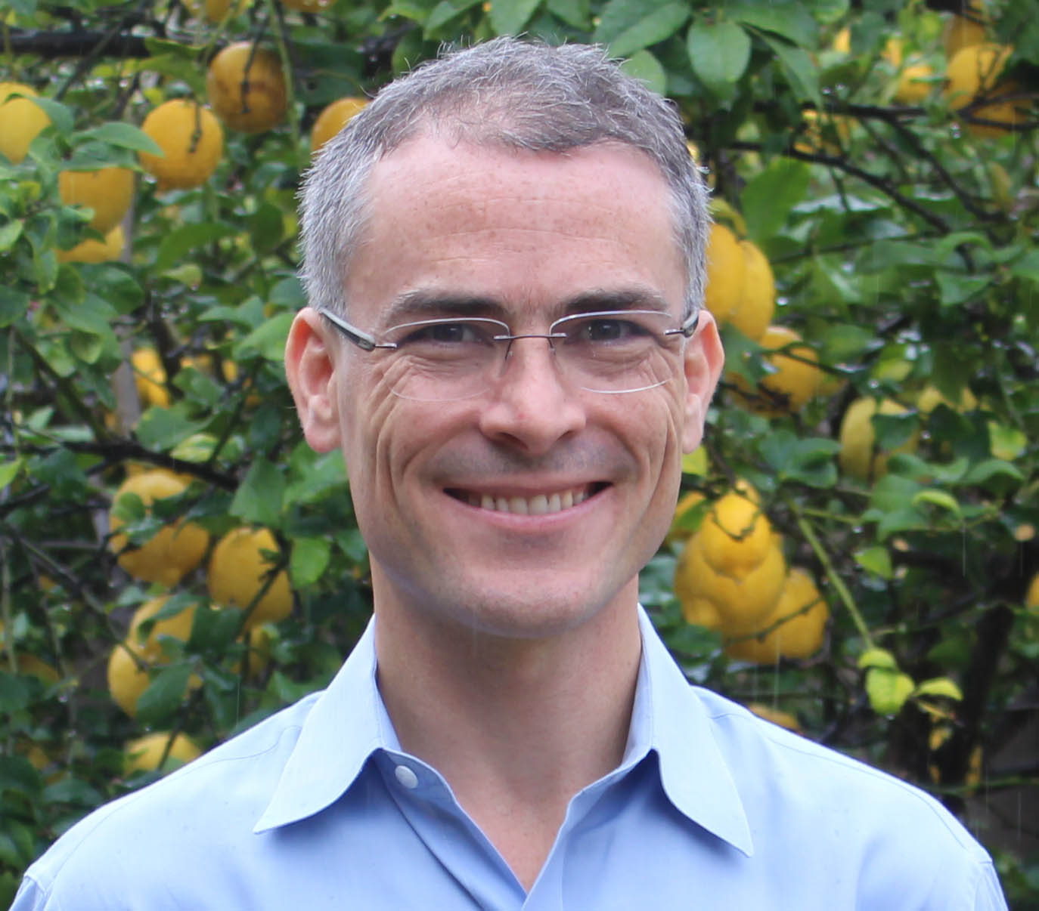

TALK TITLE
Enhanced senses, loosened priors: ERP and time–frequency signatures of a graded hierarchical inversion of visual processing under psilocybin
ABSTRACT
Classic psychedelics intensify sensory experience, yet most ERP studies report reduced stimulus-evoked responses under these drugs — an apparent paradox that M/EEG can resolve. Using a double-blind, within-subject psilocybin dataset across two visual paradigms, this talk shows that in a visual oddball task psilocybin enhanced early sensory encoding (P100) while producing a graded attenuation of every later, prediction-dependent stage — configural analysis (N170), context updating (P3a, P3b), and a late occipital negativity (N600) — the effect inverting in sign and growing up the cortical hierarchy. In the same cohort, published Kanizsa work showed a parallel, 5-HT2A-dependent reduction of ventral configural processing, alongside frontal-theta dynamics. Interpreted through predictive coding and REBUS, this indexes one coherent change: stronger bottom-up drive with relaxed top-down priors — a mechanism that plausibly underlies psilocybin's growing clinical utility across the anxiety–depression spectrum, where relaxing rigid, maladaptive priors may be therapeutic. The talk closes with falsifiable, M/EEG-tractable predictions.

🎓 17:00 Closing Remarks

Editor's Notes

- FOUR talks still need speaker-supplied titles and abstracts: Tzyy-Ping Jung, Seyed Yahya Shirazi, Virginia de Sa, and Assal Habibi. Each carries a PROVISIONAL banner with a committee-drafted title and expected scope, derived from the speaker's recent published work, so the sessions read coherently in the meantime. These must be replaced or approved before publication — please do not circulate them externally as speaker-authored.
- Kleanthis Avramidis has now supplied a full title and abstract (PRECOG project); this has been incorporated.
- Session themes were derived from the confirmed titles and abstracts, keeping every speaker in the exact time slot fixed by the committee schedule.
- SPEAKER ORDER ADJUSTED: Virginia de Sa and Kleanthis Avramidis have been swapped (de Sa now 13:30, Avramidis now 15:30). This was the single change needed to make both sessions coherent — Session 3 becomes a clean open-data-and-models pairing, and Session 5 becomes a purely clinical/mental-health block running from psychiatric measurement, through a non-pharmacological intervention, to a pharmacological one. All other speakers remain in their original slots, and the total per-slot structure is unchanged.
- Both affected speakers should be told their slot has moved before the program circulates.
- All biographies were drafted from public institutional and profile pages and should be checked with each speaker before publication.
- Speaker photographs have been imported from the Google Docs version and are embedded here. Each was fitted to a uniform square without cropping, so no face is cut off; a few images carry white margins as a result. Please eyeball that every photo matches its speaker — they were matched by their position in the source document, not by recognition.
- Carried over from the Google Docs version: Richard Leahy's talk title is now "Opening of the San Diego Garden & Intro to multimodal neuroimaging". A "[ToDo: Insert Final program]" marker also appears near Day 1 in that version — the final Day 1 running order can be dropped in once fixed.
- Day 1 exhibitor talks (11:30, TBC) can be added as a further section once the exhibitors are confirmed.
- CHANGE IN THIS DRAFT: the Wednesday afternoon practicum is now a single unified session, "Deep Learning EEG Methods and Practice", replacing the parallel Brainstorm and EEGLAB hands-on workshops. EEGLAB and Brainstorm remain covered in the Day 1 morning introductions; consider adding links to the existing online tutorials for both platforms in the delegate pack so that attendees who wanted the hands-on software track are not left without a route in.
- The practicum instructor list and the call-for-contributors box are committee-facing placeholders. Both should be resolved — and the amber box deleted — before the program is circulated publicly or sent to the wider UCSD list.
- Online-only participation: attendees who cannot travel can be registered under the "attendee" Garden label to join the sessions remotely.

